In order to do our unit testing we will use two very popular libraries namely jest and enzyme. Jest is a library written by facebook and has become very popular in the past few years. Jest will help us to do all our assertions and enzyme will help us render React components in testing mode.

Steps :

1. If we use npx create-react-app so jest is already installed , else use below command to install jest:-   
   **npm i jest**
2. Install enzyme :-  
    **npm i --save-dev enzyme enzyme-adapter-react-16**

Imp -- At the moment, Enzyme has adapters that provide compatibility with React 16.x, React 15.x, React 0.14.x and React 0.13.x. so check your react version accordingly to prevent errors.

1. In setupTests.jsx or any configurations file configure your jest and enzyme adapter so that we can use it .
2. import '@testing-library/jest-dom';
3. import Enzyme from 'enzyme';
4. import Adapter from 'enzyme-adapter-react-16';
5. Enzyme.configure({ adapter: new Adapter() });

4) We can run test case : **npm run test**

5) To check test cases coverage : **npm test -- --coverage –watchAll**

**Pure Components**

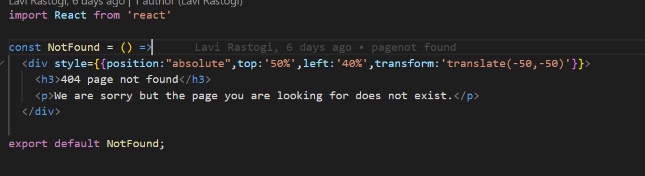

Unit test case example / Code snippets to test above Pure component

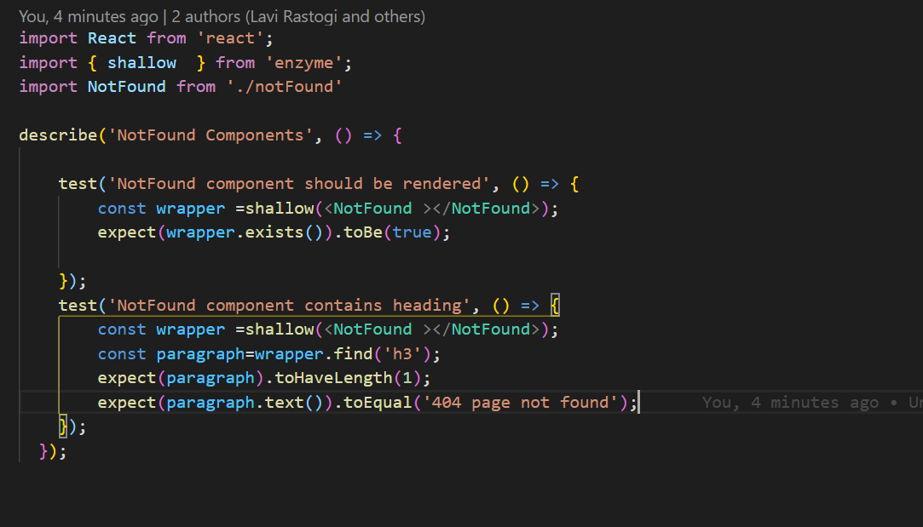

[**Action Creators**](https://redux.js.org/recipes/writing-tests#action-creators)

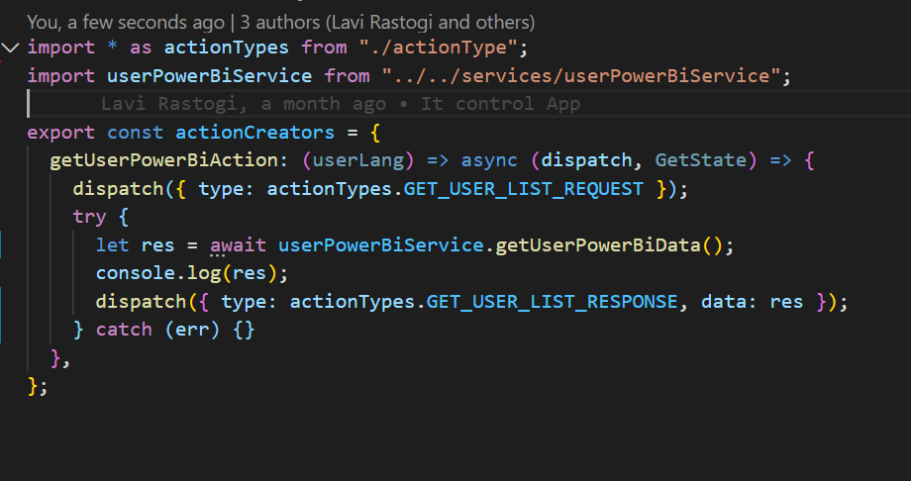

Unit test case example / Code snippets to test above Action Creator

Install redux-mock-store : **npm i redux-mock-store**

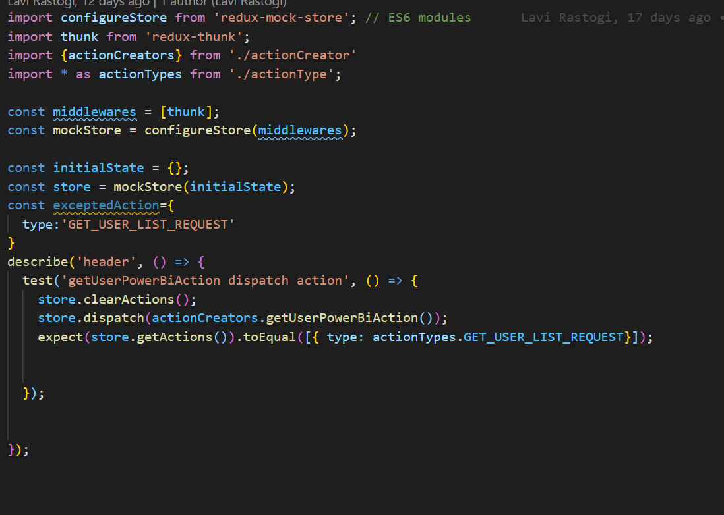

**REDUCERS**

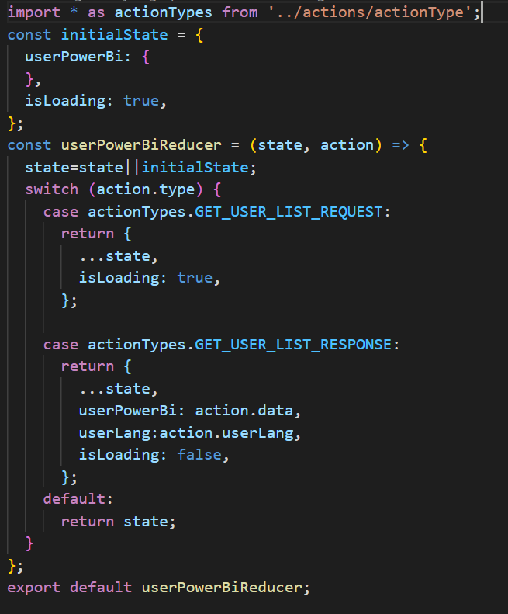

Unit test case example / Code snippets to test above Reducer

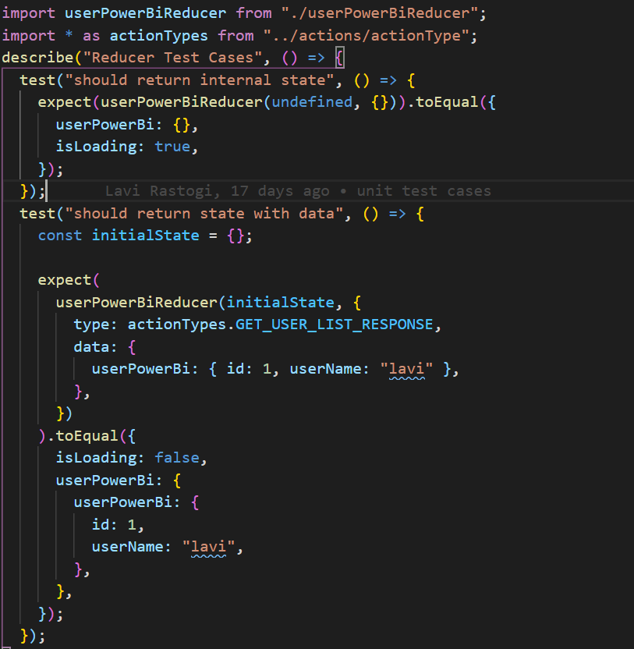

[**Connected Components**](https://redux.js.org/recipes/writing-tests#connected-components)

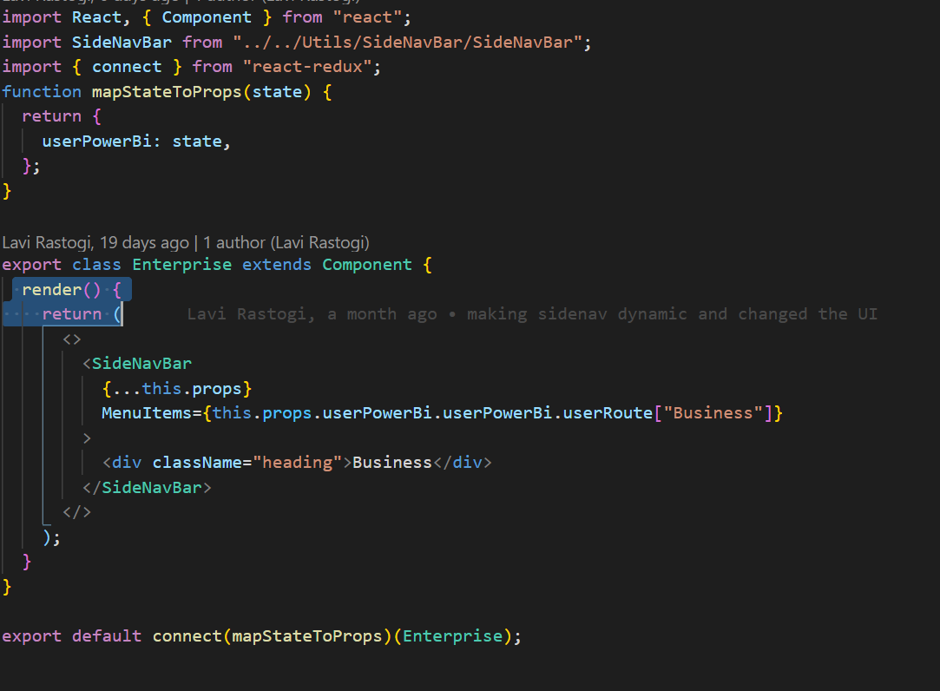

Unit test case examples / Code snippets to test above Connected Component.

**Now there are 2 things:**

1. To test your components without connect so export your Enterprise class and mock the data and pass in props like a simple class component. Below is example :-

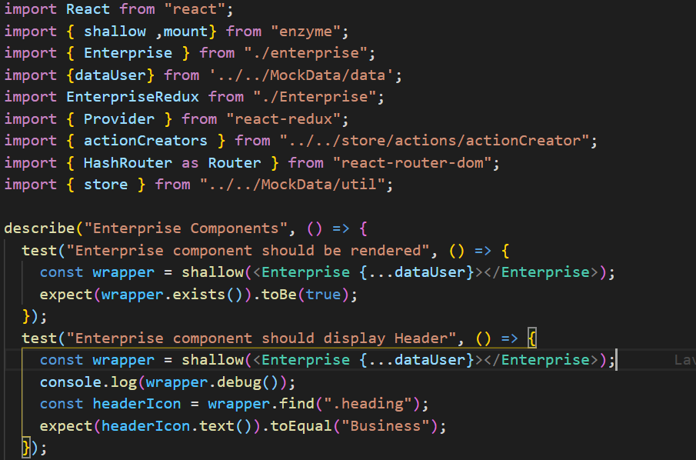

b) Unit test case examples / Code snippets for above redux component.

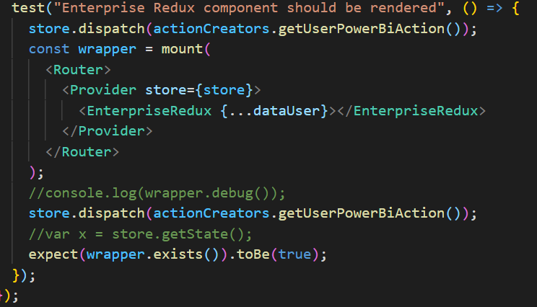

**Unit test case examples / Code snippets for Routing**

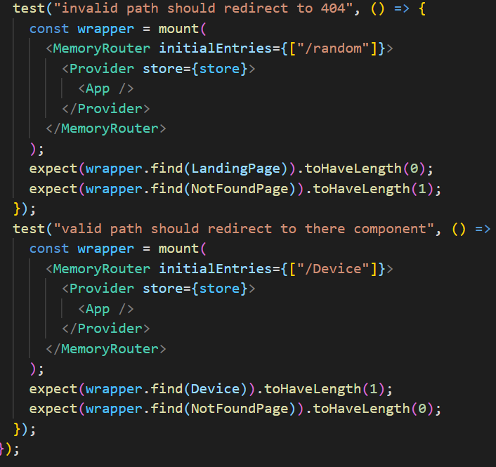

**Unit test case examples / Code snippets for API Call Testing**

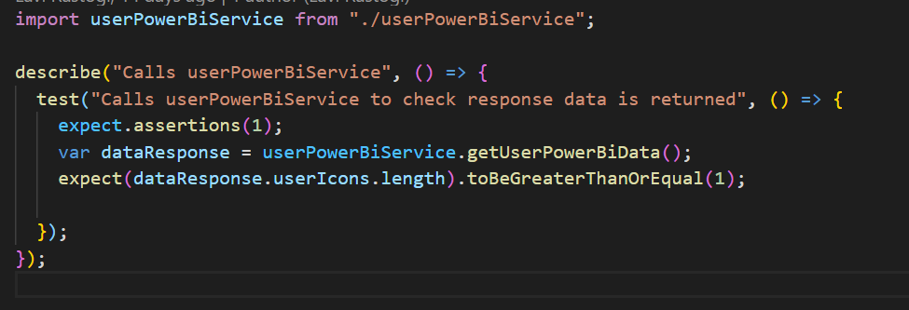

**Unit test case examples / Code snippets for Mocking A Click Function**

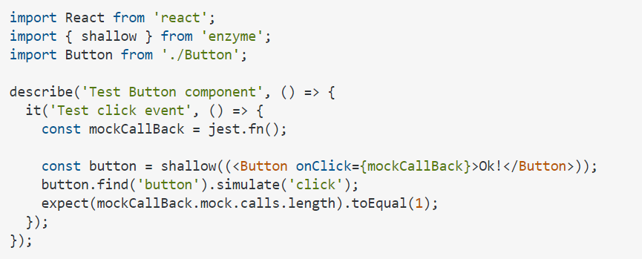

Below are important links contains cheat sheet for jest and enzyme

JEST:

<https://github.com/sapegin/jest-cheat-sheet>.

ENZYME:

<https://devhints.io/enzyme>.

<https://gist.github.com/jahe/9bf2cb1f849b7ed96c6ce20ede7f66a2>.

**MOCKING AXIOS API :**

https://www.robinwieruch.de/axios-jest